HOMEWORK #1

Name _____________________________________________ Date _______________ Period __________
Land Bridge Theory
Directions: Examine the map and answer the question below.
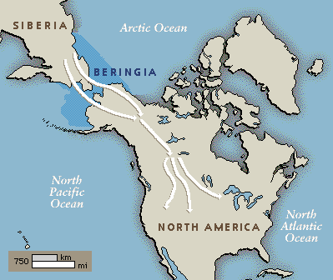

Think Question#1: According to the Land Bridge Theory, what may be some reasons why people traveled over the land mass Beringia during the Ice Age?

Think Question #2: According to the theory, why might these Early Americans have stayed and settled in North America?

